Simon Light

[Email address]

Abstract

[Draw your reader in with an engaging abstract. It is typically a short summary of the document.   
When you’re ready to add your content, just click here and start typing.]

PDP

Unit 1 Assignment 3

Contents

Qualifications 2

Strengths and Weaknesses 2

Goals 3

Short term 3

Mid term 3

Long term 3

Qualifications 4

Strengths and Weaknesses 5

Goals 6

Short term 6

Mid term 6

Long term 6

Progress 6

30/09/2015 6

17/10/2015 6

10/11/2015 6

P7.

Simon Light – PDP

# Qualifications

GCSE’s:

* A – Maths
* B – Double science, English Lit and Lang, Business, Drama, IT
* C – Spanish

A-levels (currently studying):

* Computer Science
* BTEC IT Level 3
* Maths
* Product Design

Extracurricular:

* Level 2 canoe and kayak
* 2 start award Cadets
* Green Card award – RCC

# Strengths and Weaknesses

|  |  |
| --- | --- |
| Ability | September rating |
| Technical Knowledge | 6 |
| Working Procedures | 5 |
| Team Working | 7 |
| Numeric Skills | 7 |
| Creativity | 5 |
| Determination | 4 |
| Independence | 6 |
| Integrity | 4 |
| Tolerance | 7 |
| Dependability | 7 |
| Problem Solving | 8 |
| Leadership | 5 |
| Confidence | 6 |
| Self-Motivation | 6 |

# Goals

## Short term

* Get a distinction Unit 1
* Revise for all of the upcoming progress tests
* Get fully trained at work
* Get my team selected for the PBA project

## Mid term

* Save enough to learn to drive
* Get a MOS
* Build a new Computer with a 3 screen set up

## Long term

* Pass A-Levels
* Seek an IT Apprenticeship
* Be self-reliant

P8.

Simon Light – PDP

# Qualifications

GCSE’s:

* A – Maths
* B – Double science, English Lit and Lang, Business, Drama, IT
* C – Spanish

A-levels (currently studying):

* Computer Science
* BTEC IT Level 3
* Maths
* Product Design

Extracurricular:

* Level 2 canoe and kayak
* 2 start award Cadets
* Green Card award – RCC

# Strengths and Weaknesses

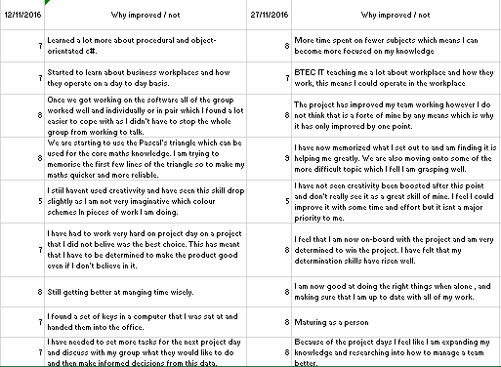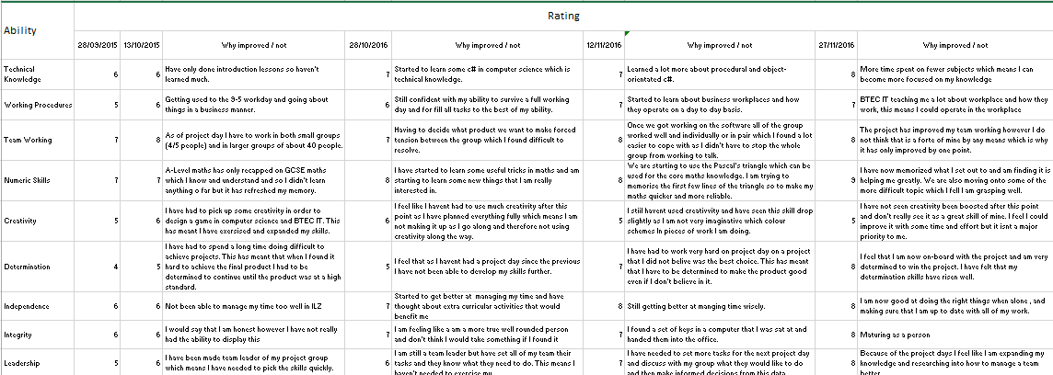

# Goals

## Short term

* Get a distinction Unit 1
* Revise for all of the upcoming progress tests
* Get fully trained at work
* Get my team selected for the PBA project

## Mid term

* Save enough to learn to drive
* Get a MOS
* Build a new Computer with a 3 screen set up

## Long term

* Pass A-Levels
* Seek an IT Apprenticeship
* Be self-reliant

# Progress

## 30/09/2015

* Have updated this report
* Started revising computer science
* Have finished my last trainee shift
* I pitched to the project leader of the PBA project

## 17/10/2015

* Achieved distinction in this assignment without any corrections.
* Created a plan on what I need to save money for so that I can manage it more effectively
* Fully revised for all progress tests

## 10/11/2015

* Started to move money into a savings account to achieve higher interest rates
* Completed all training for outlook MOS and am just waiting to take the test
* Have made a plan on my pc set up and have got three screens.
* Have been working hard on all of my A-level courses
* Looked into apprenticeships at GCHQ and other security companies.

M3.

If you are aware of your preferred learning style how can you use that knowledge to make you’re learning more effective” (1 page) explain learning style, describe presentation, answer question

The three types of learners are:

Kinaesthetic – learn by doing things.

Visual – learn by seeing things.

Auditorial – learn by hearing things.

I am a kinaesthetic learner. This means that I learn best by doing things. This means that I need to modify my experiences and tasks when learning so that I can learn better. This includes making things into quizzes, contests and typing things out.

This means that I can learn to the best of my ability and know how to modify information I am given to make it best for me

D2.

My PDP will need improvement. To do this I will follow the acronym SMART. This stands for:

Specific – Make your goal precise and specific.

Measurable – Make sure that you can show at the end how much you have done.

Attainable – Make sure that it is a goal that you can show that you have achieved it.

Realistic – Is it actually do able?

Time – Set a time period for you to complete this goal.

An example of a goal I have at the moment that doesn’t for fill this task is “revise all of the upcoming tests”. This doesn’t follow the acronym.

The way that I would change this is by saying “fully read over all notes done in class on the following maths, computer science and decision and achieve over 70%. This does follow SMART and so it is a better goal.